Walt Disney died in December, 1966, when he was 65. But he is not forgotten.

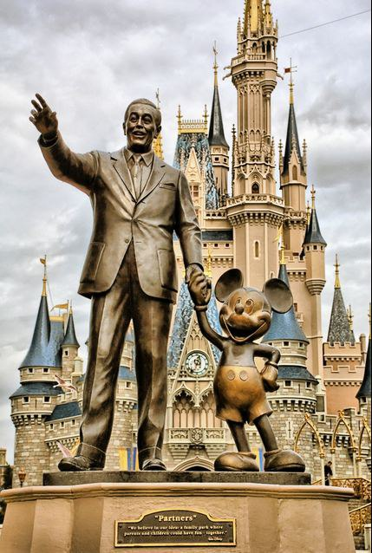

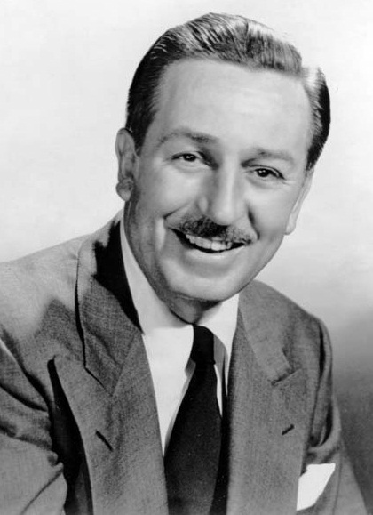 Do you know this man? I think that everybody knows this man. His name is Walt Disney.
Andreeva Natalia and Kozhevnikova Svetlana
Form 11

Life Walt Disney
Walter Elias Disney was born on December 5, 1901, in Chicago, Illinois, USA.
When Walt was 7, he read texts, studied arithmetic, writing, geography and spelling. When he had time, Walt loved to draw, but he didn’t have any paper and pencils on his own. His Aunt Maggie gave him paper and pencils.
By 1923 Hollywood had become a company town. In Hollywood Walt rented an old camera and a garage which he turned into a small studio.
In 1927 the first movie with sound was shown. One day Walt had an idea to make a mouse the main character of the cartoons.

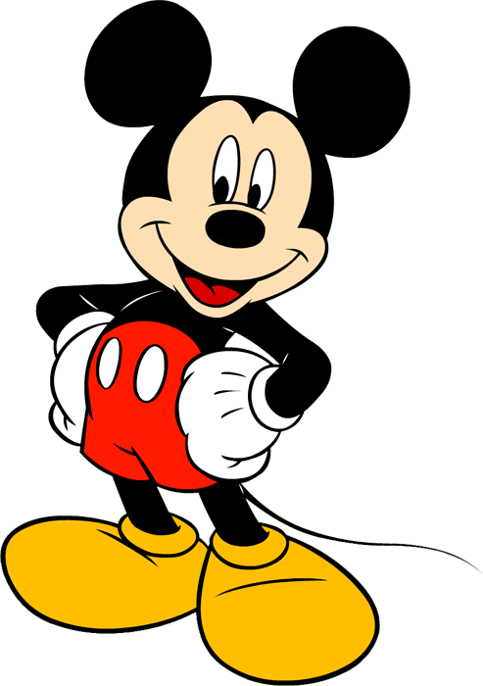

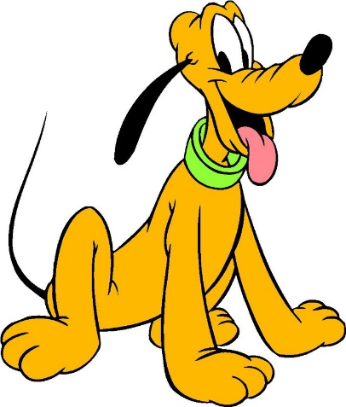
1928 the audience saw Mickey Mouse on the screen for the first time.
Then came other characters: Snow White and the seven dwarfs, Donald Duck, Winnie-the-Pooh, Pluto, Peter Pan, Aladdin, Chip and Dale and many, many others.
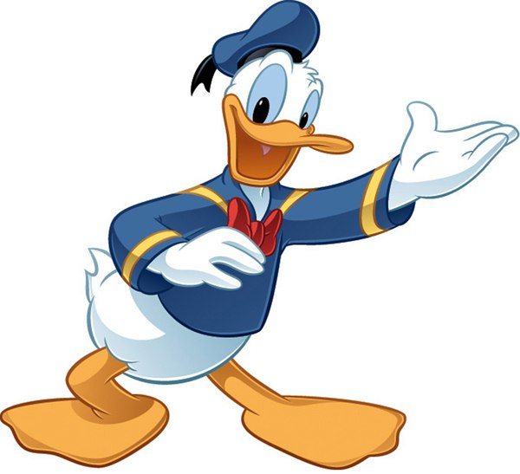

One day an idea came to Disney. He wanted to create an amusement park for children and their parents. So he built Disneyland in California near Los Angeles. On a huge territory everything is arranged as if it were a fairy land. Disneyland cannot be compared with any other attraction parks.

Park is named after its creator Walt Disney. The park is divided into five theme parks and Frontierland.

